Concatenation program

#! - path or location for shell

“ “ - string ‘ ‘ - string # - comment

$ - identify as a variable or value

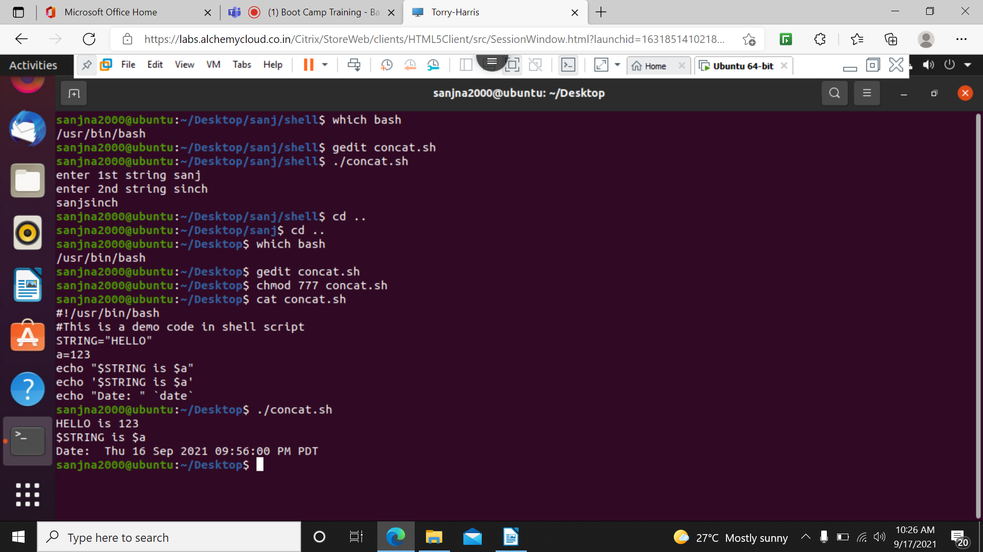

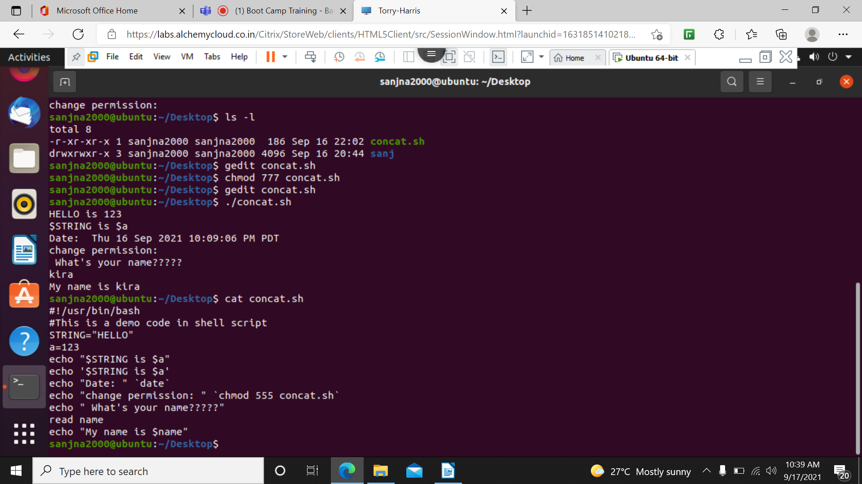

$0 – name of script

$# - number of command line arguments

$$ - process ID of the shell

$@/\* - all command line arg passed in script

$? - return code/ exit code of last

If condition:

If [condition]

Then

Statement

fi

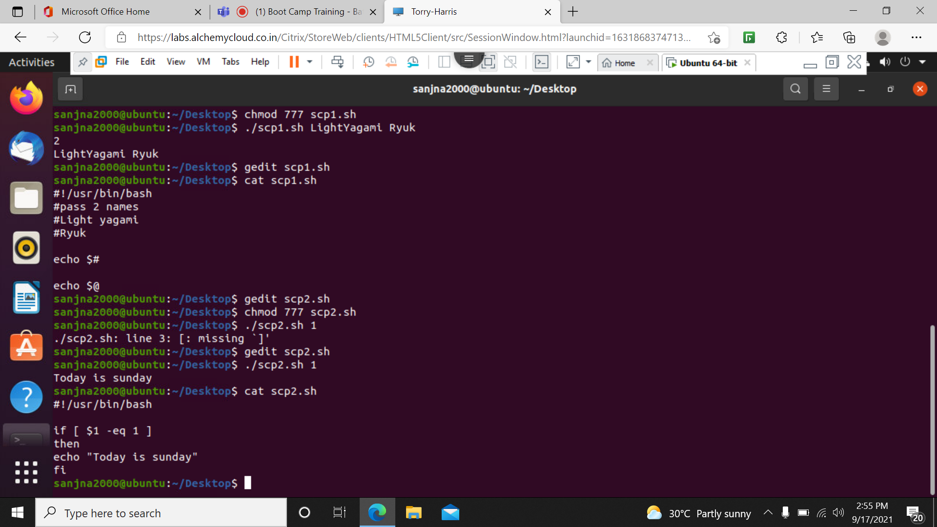

If else condition:

If [condition]

Then

Statement

Elif [condition]

Then

Statement

Else [condition]

Statement

fi

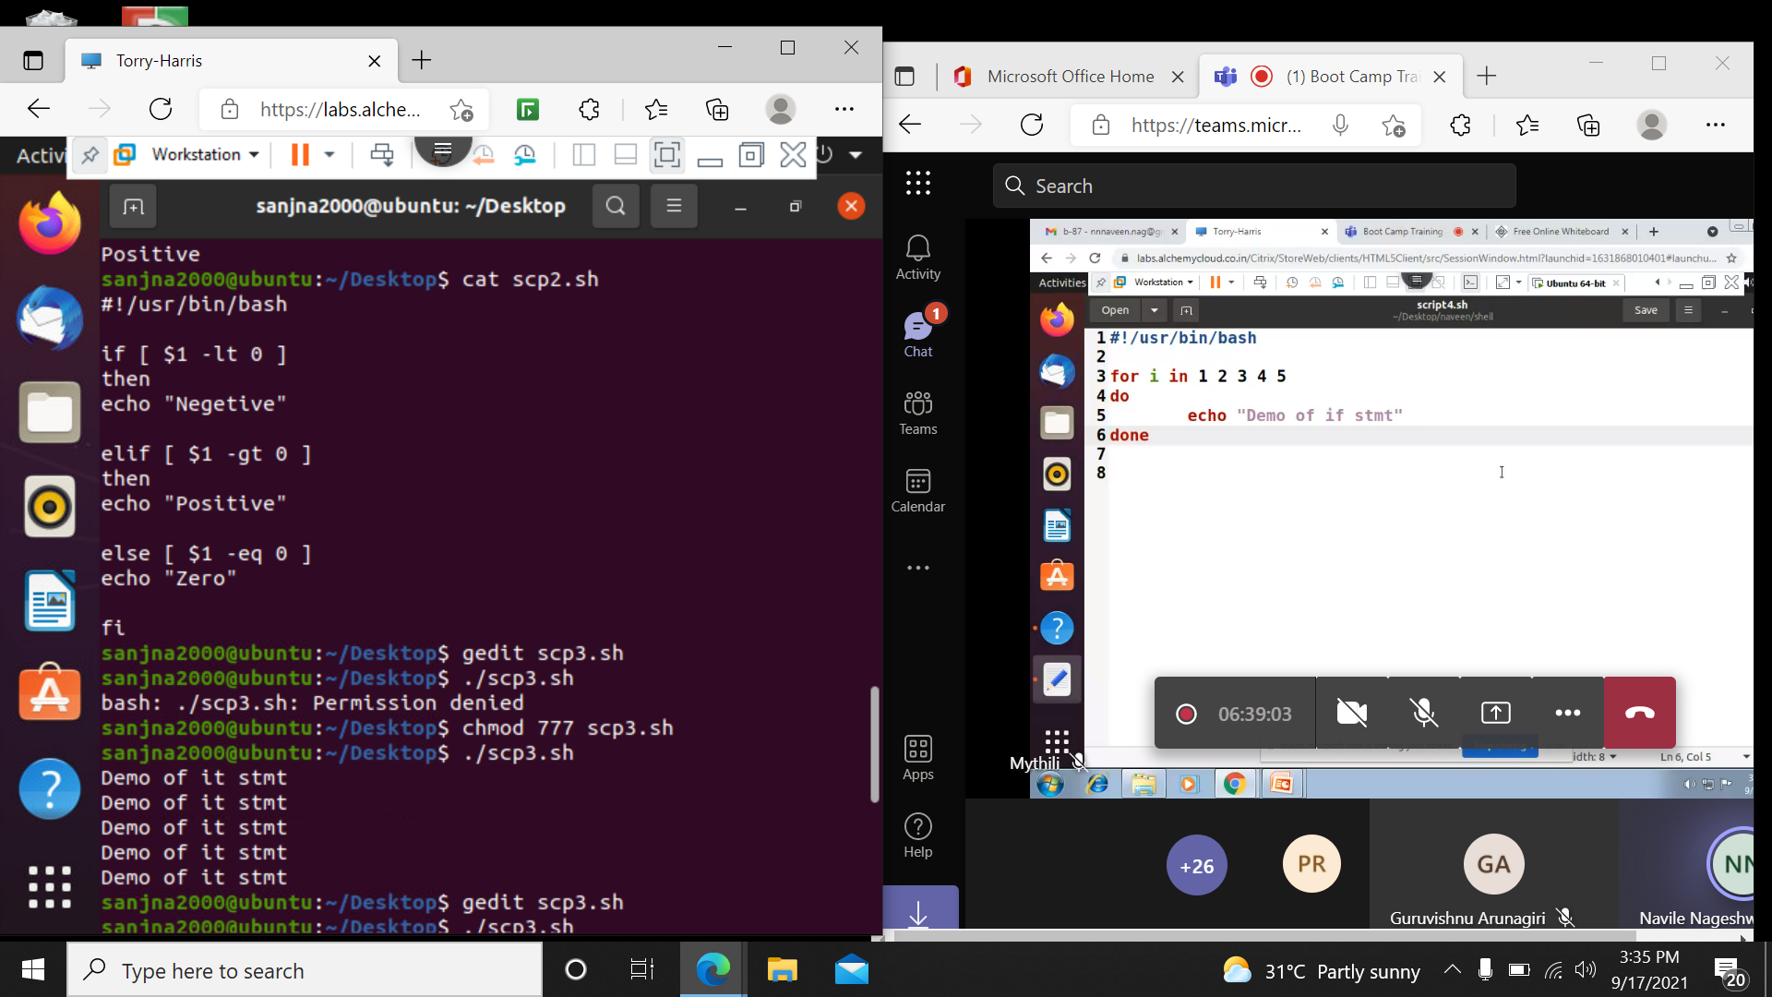

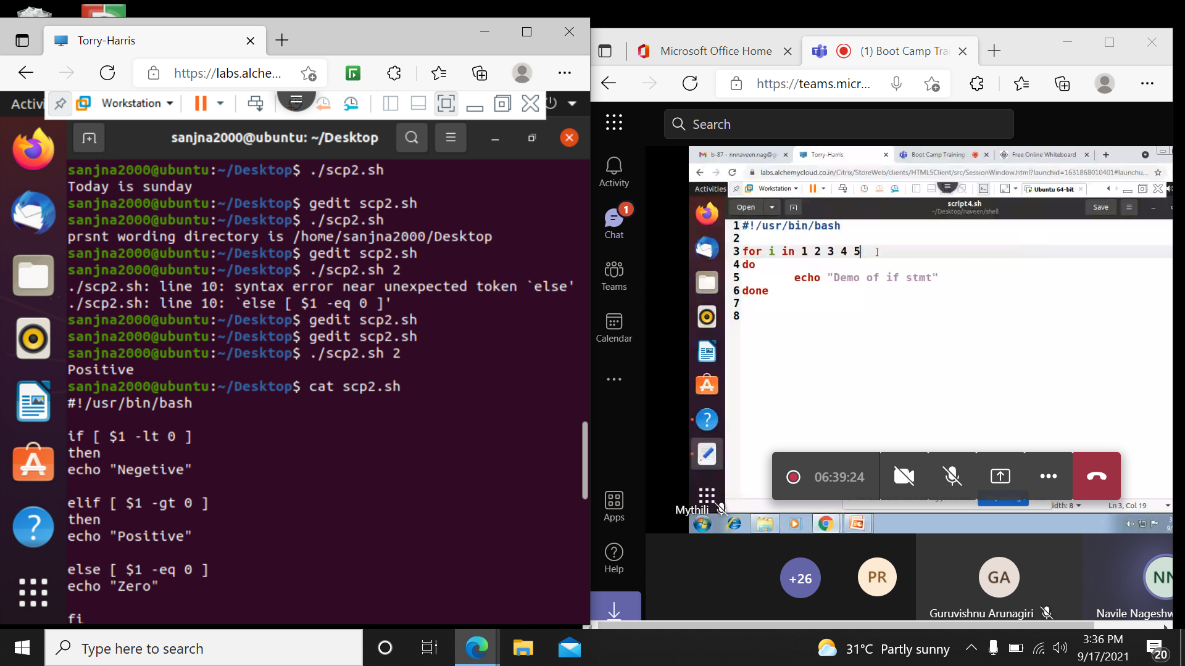

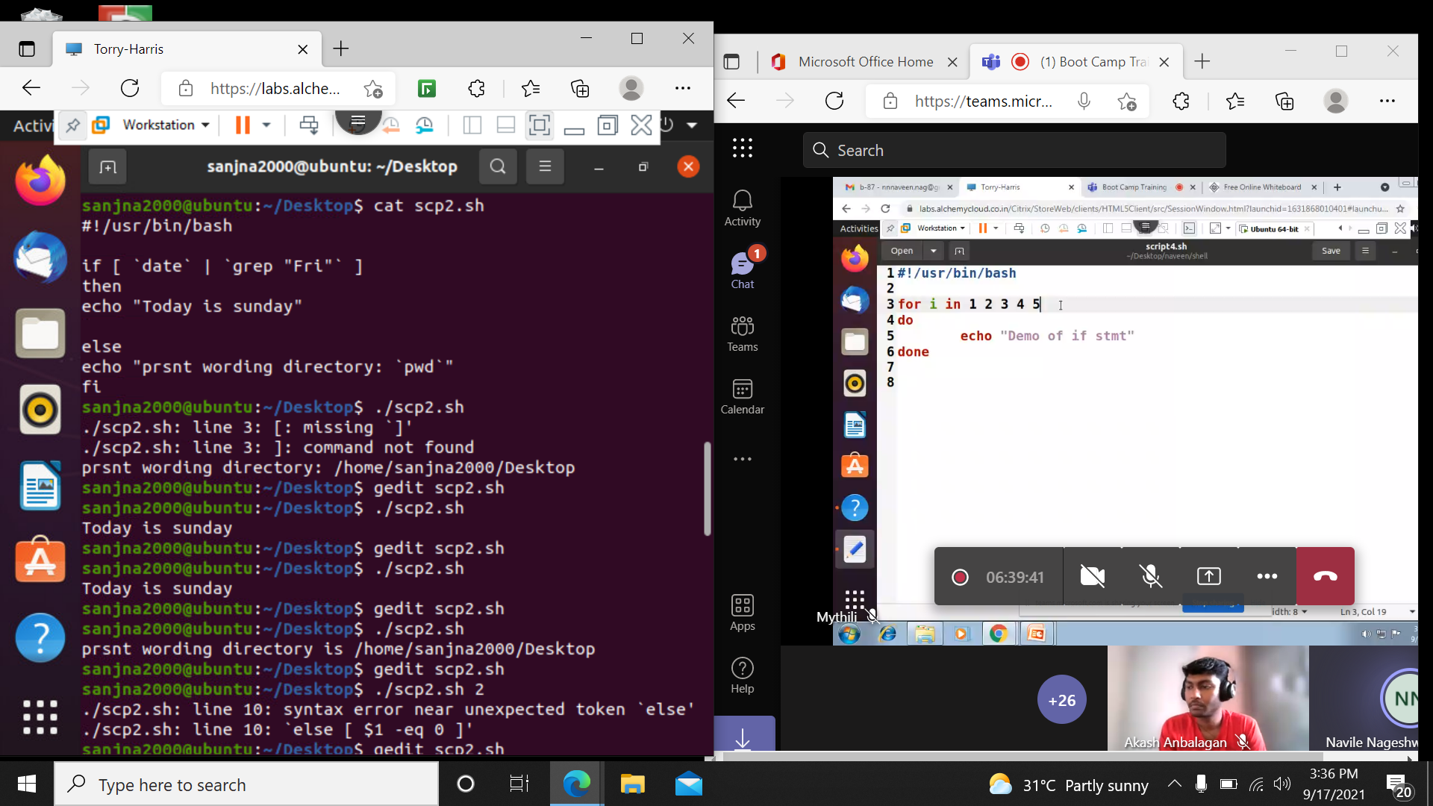

For statement:

For(condition)

Do

Command

done

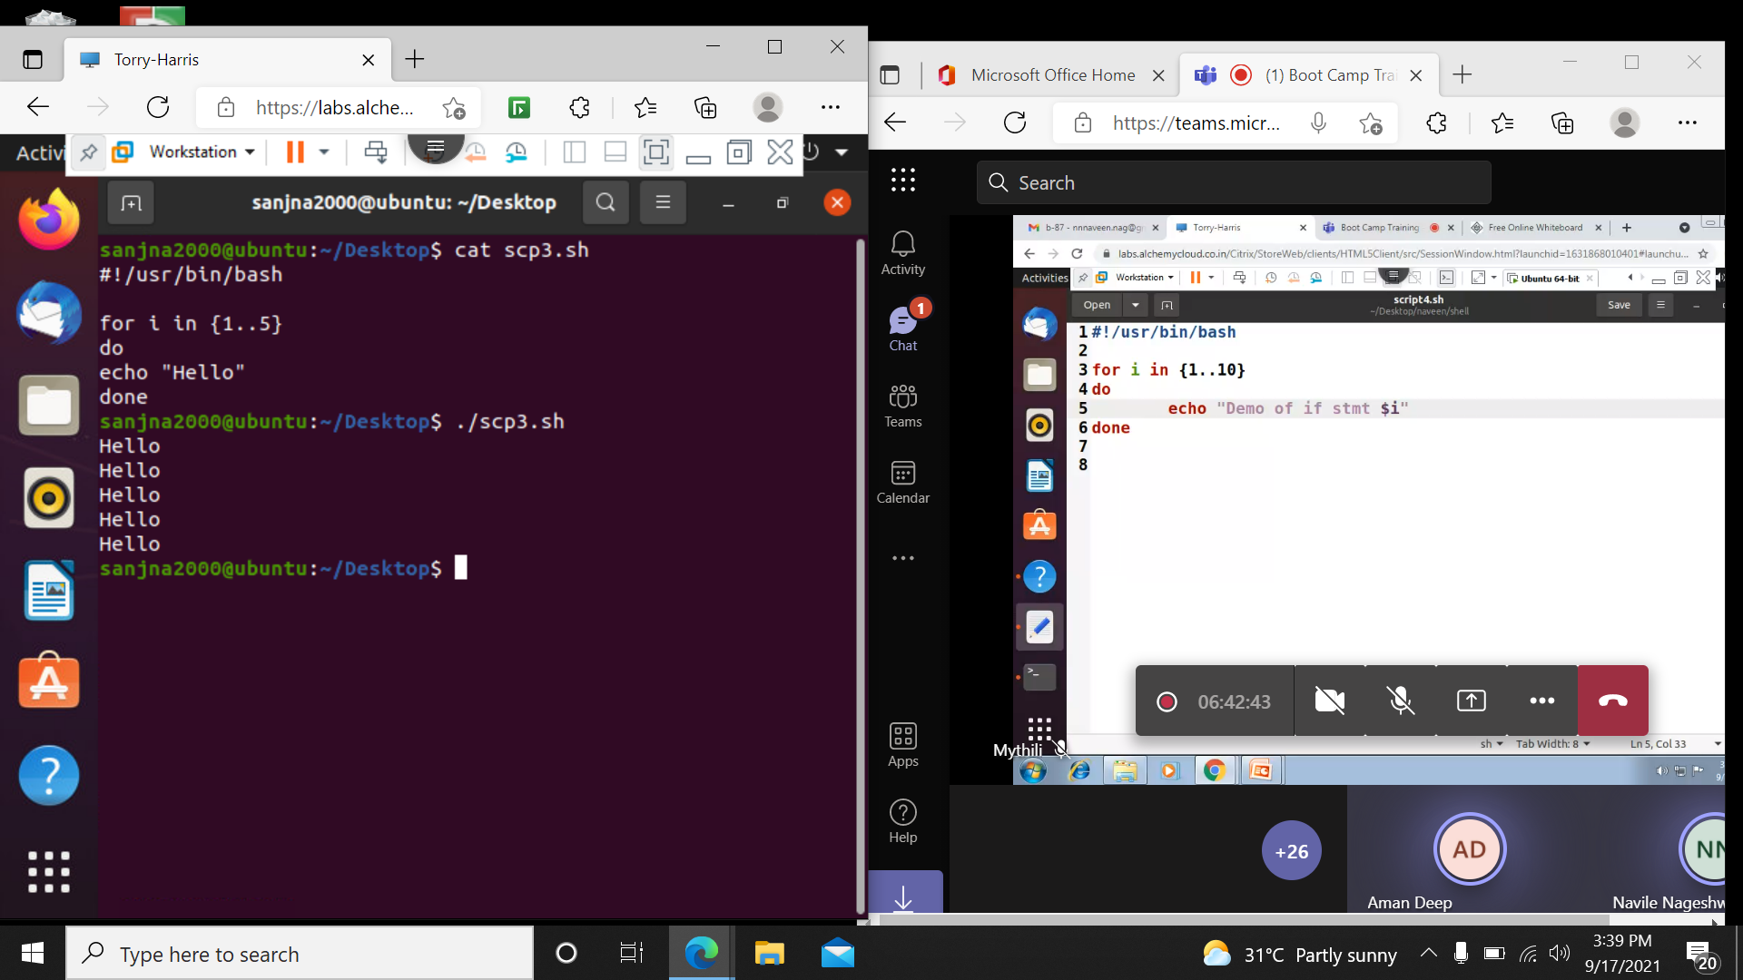

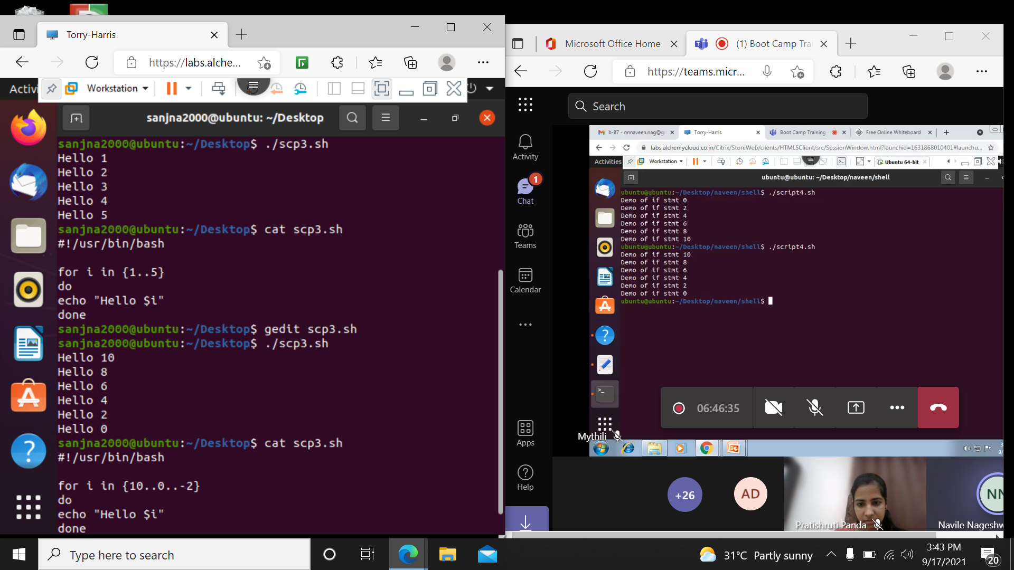

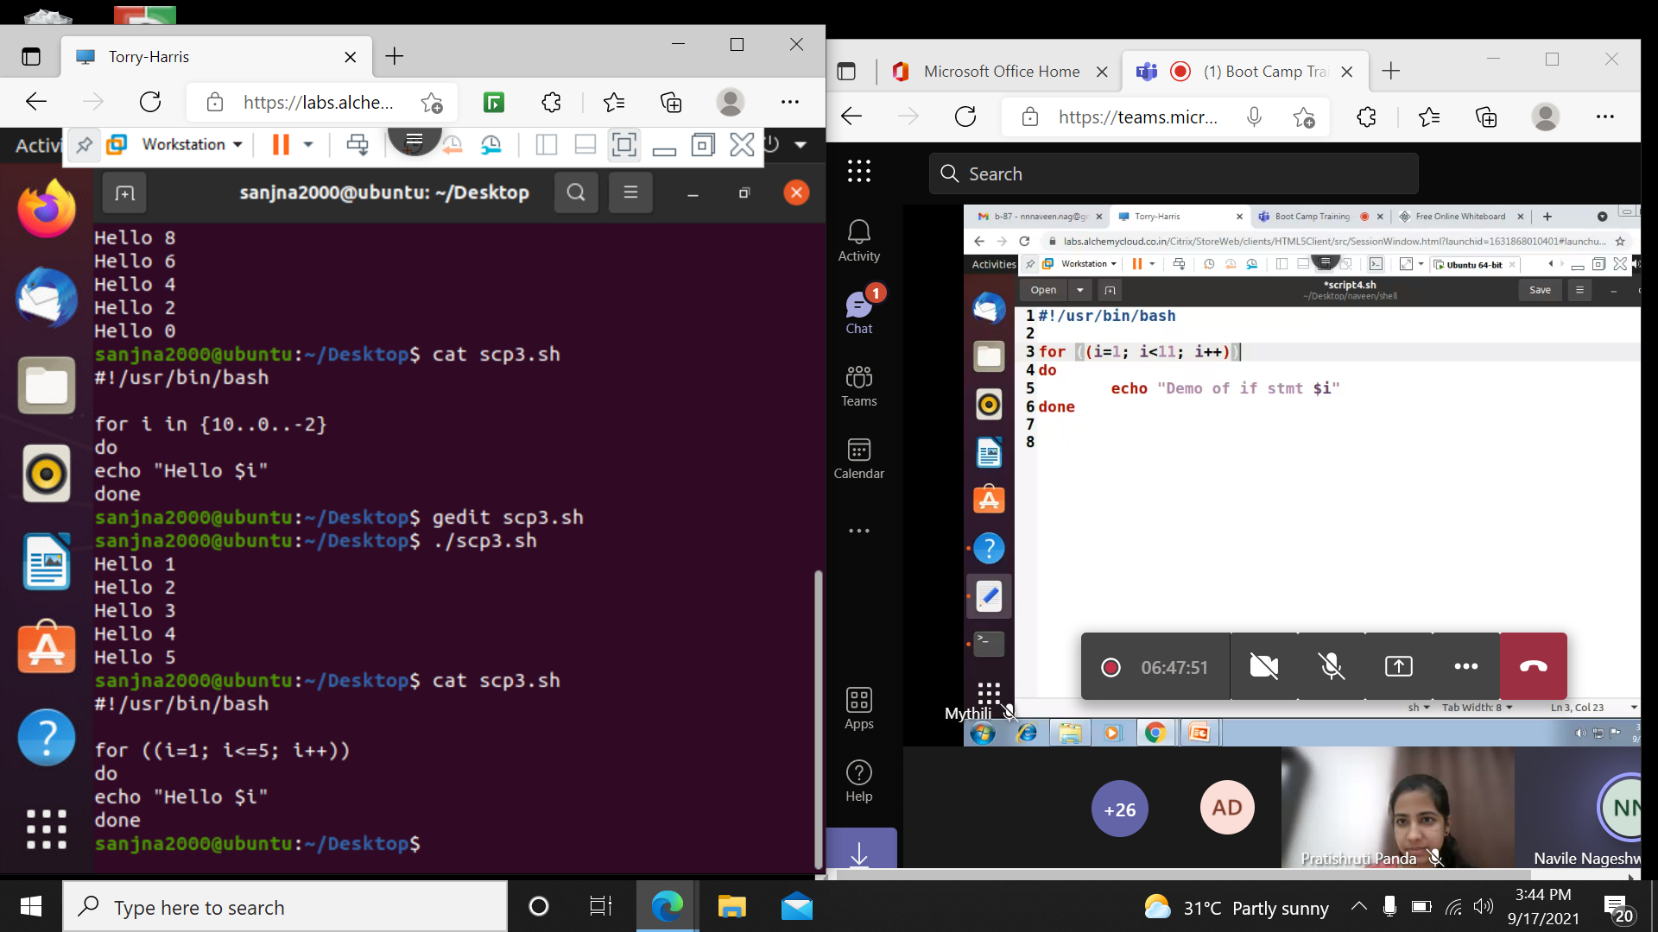

While condition:

While [condition]

Do

Command

done

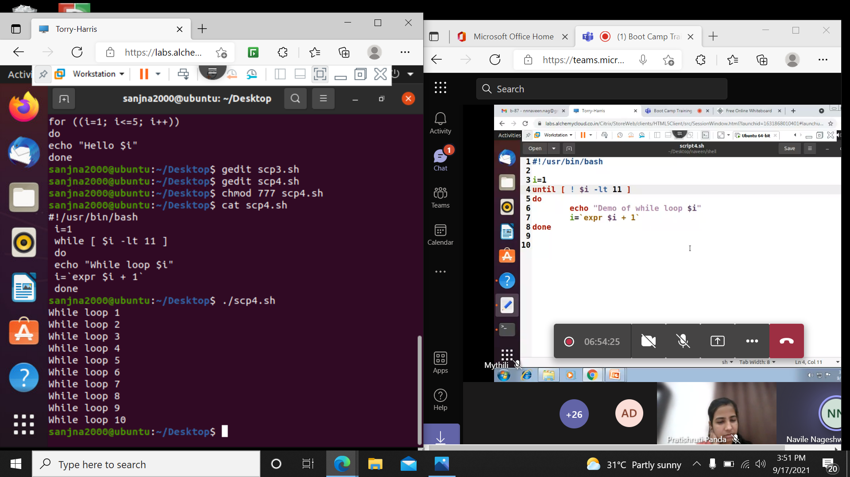

Until condition: Until is opposite of while

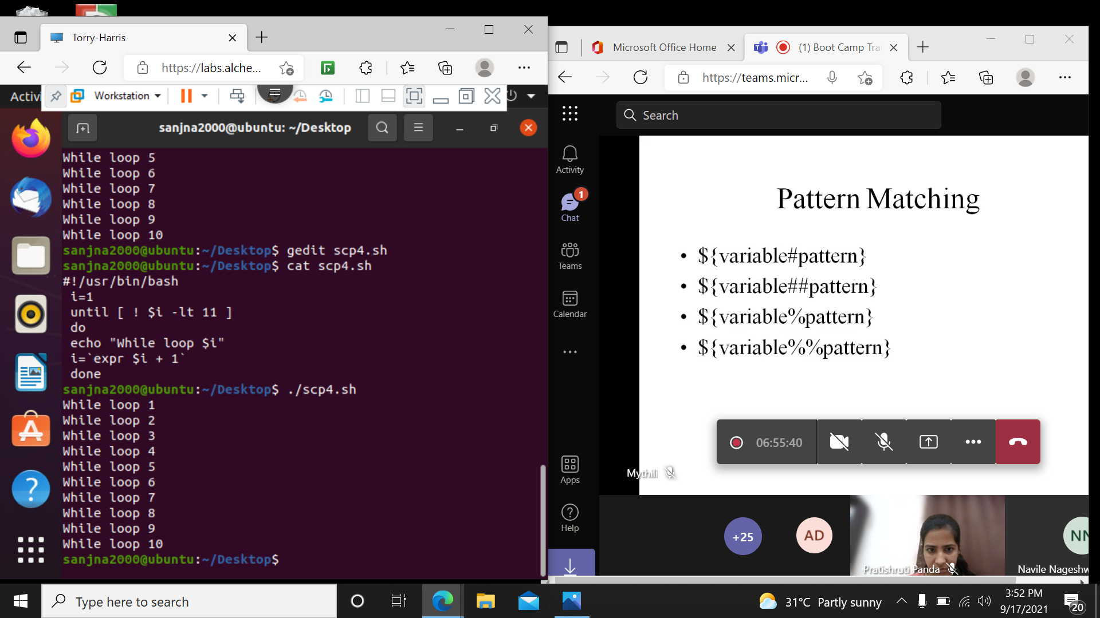

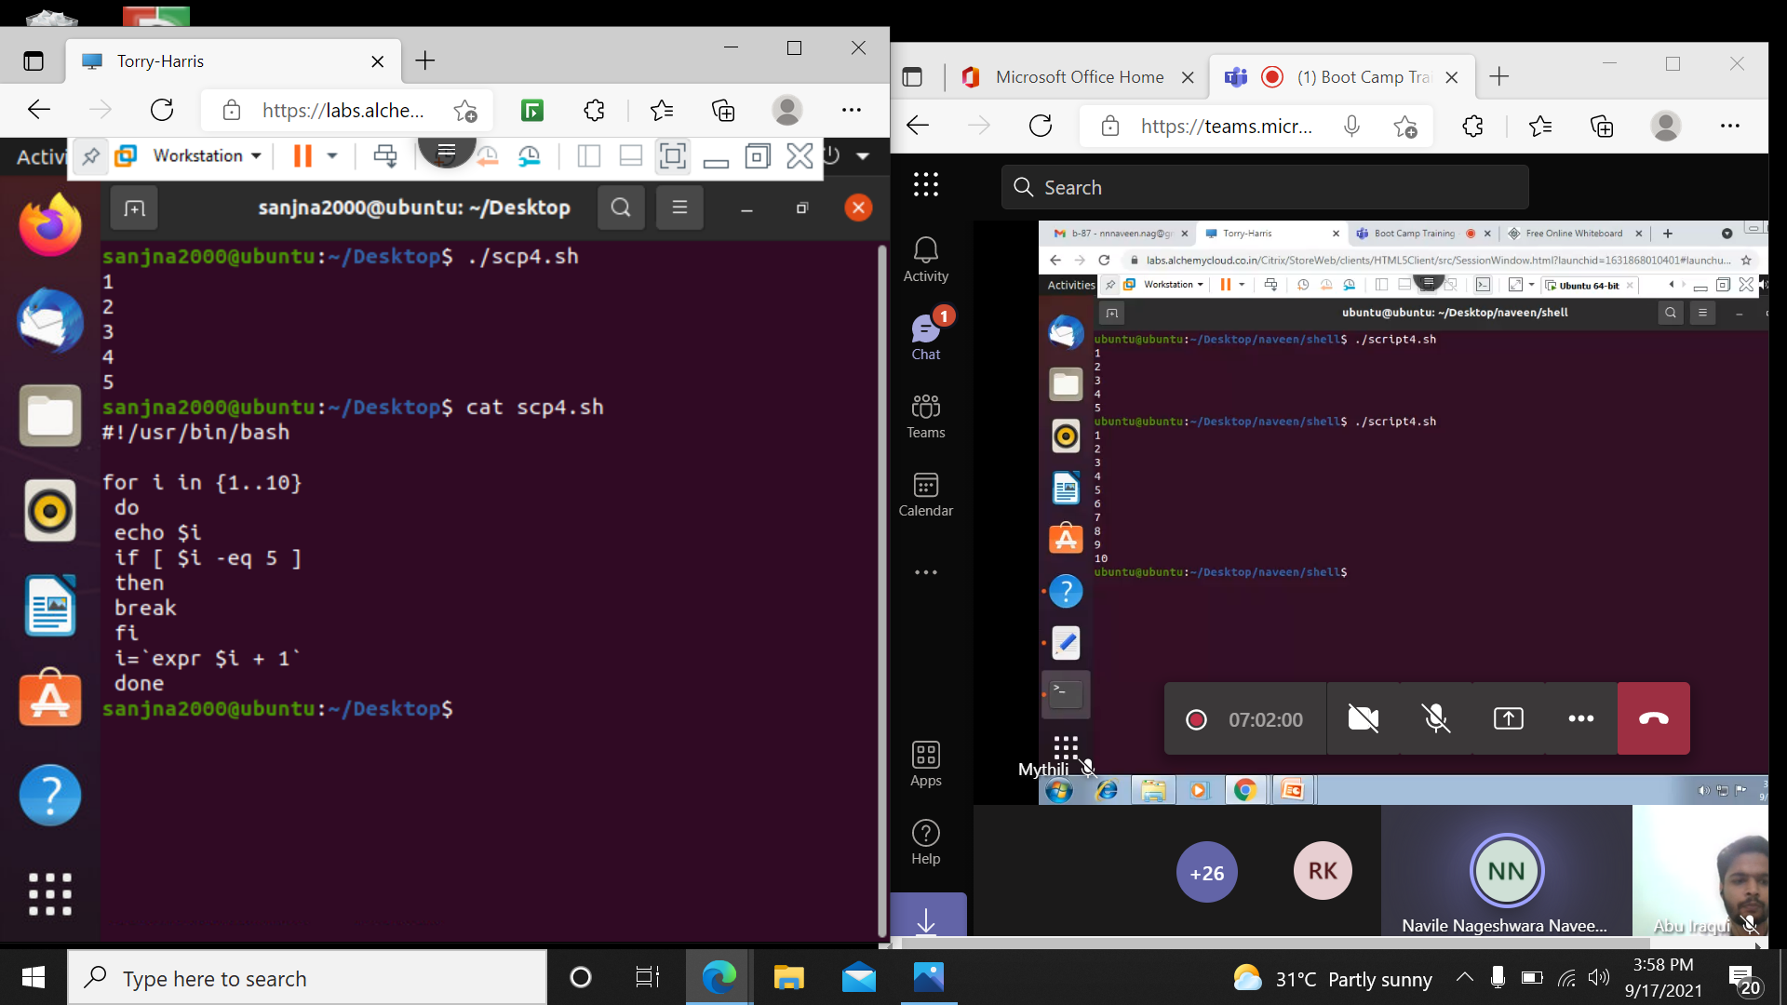

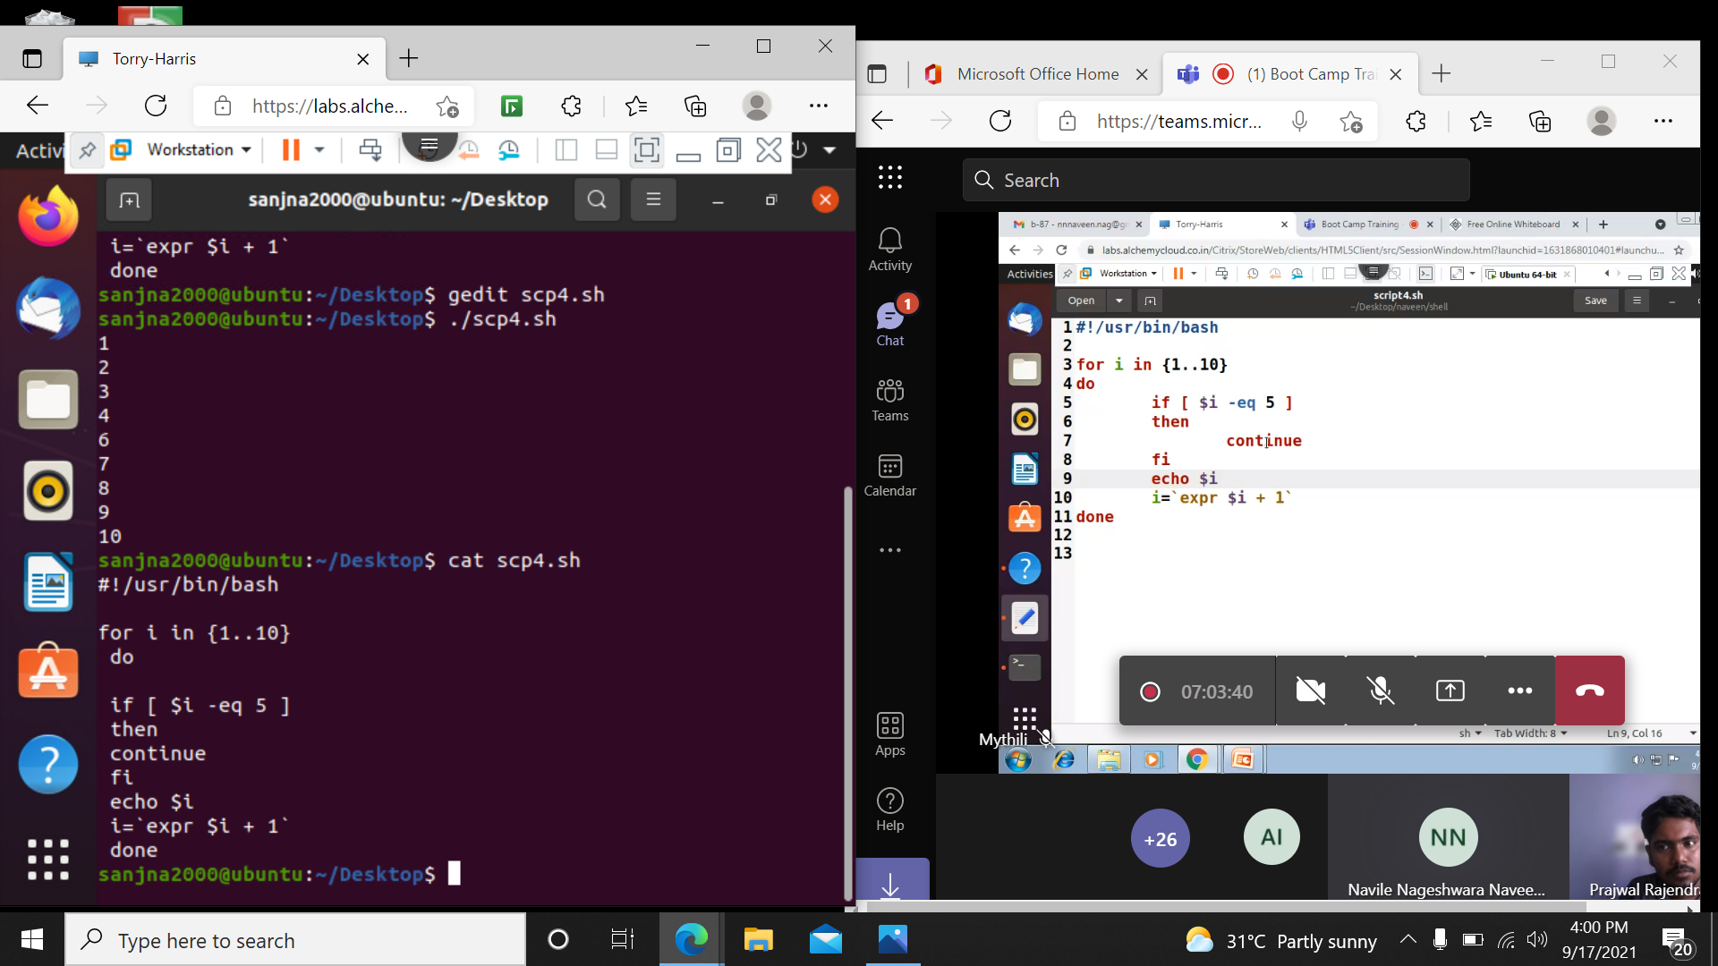

Function:

